**Habitat suitability of Secale Cereale in present and future climate using MaxEnt distribution models.**

**Introduction**

Secale cereale (Rye) is a food crop of the Poaceae family and the grains of this plant are used to as food source for humans as well as livestock. Wildtype Rye originated for Turkey and was spread to Europe around 1500 BC. Nowadays Rye is cultivated all over the world but Europe remains the main producer of Rye. Figure 1 shows the worldwide occurrence of Rye.

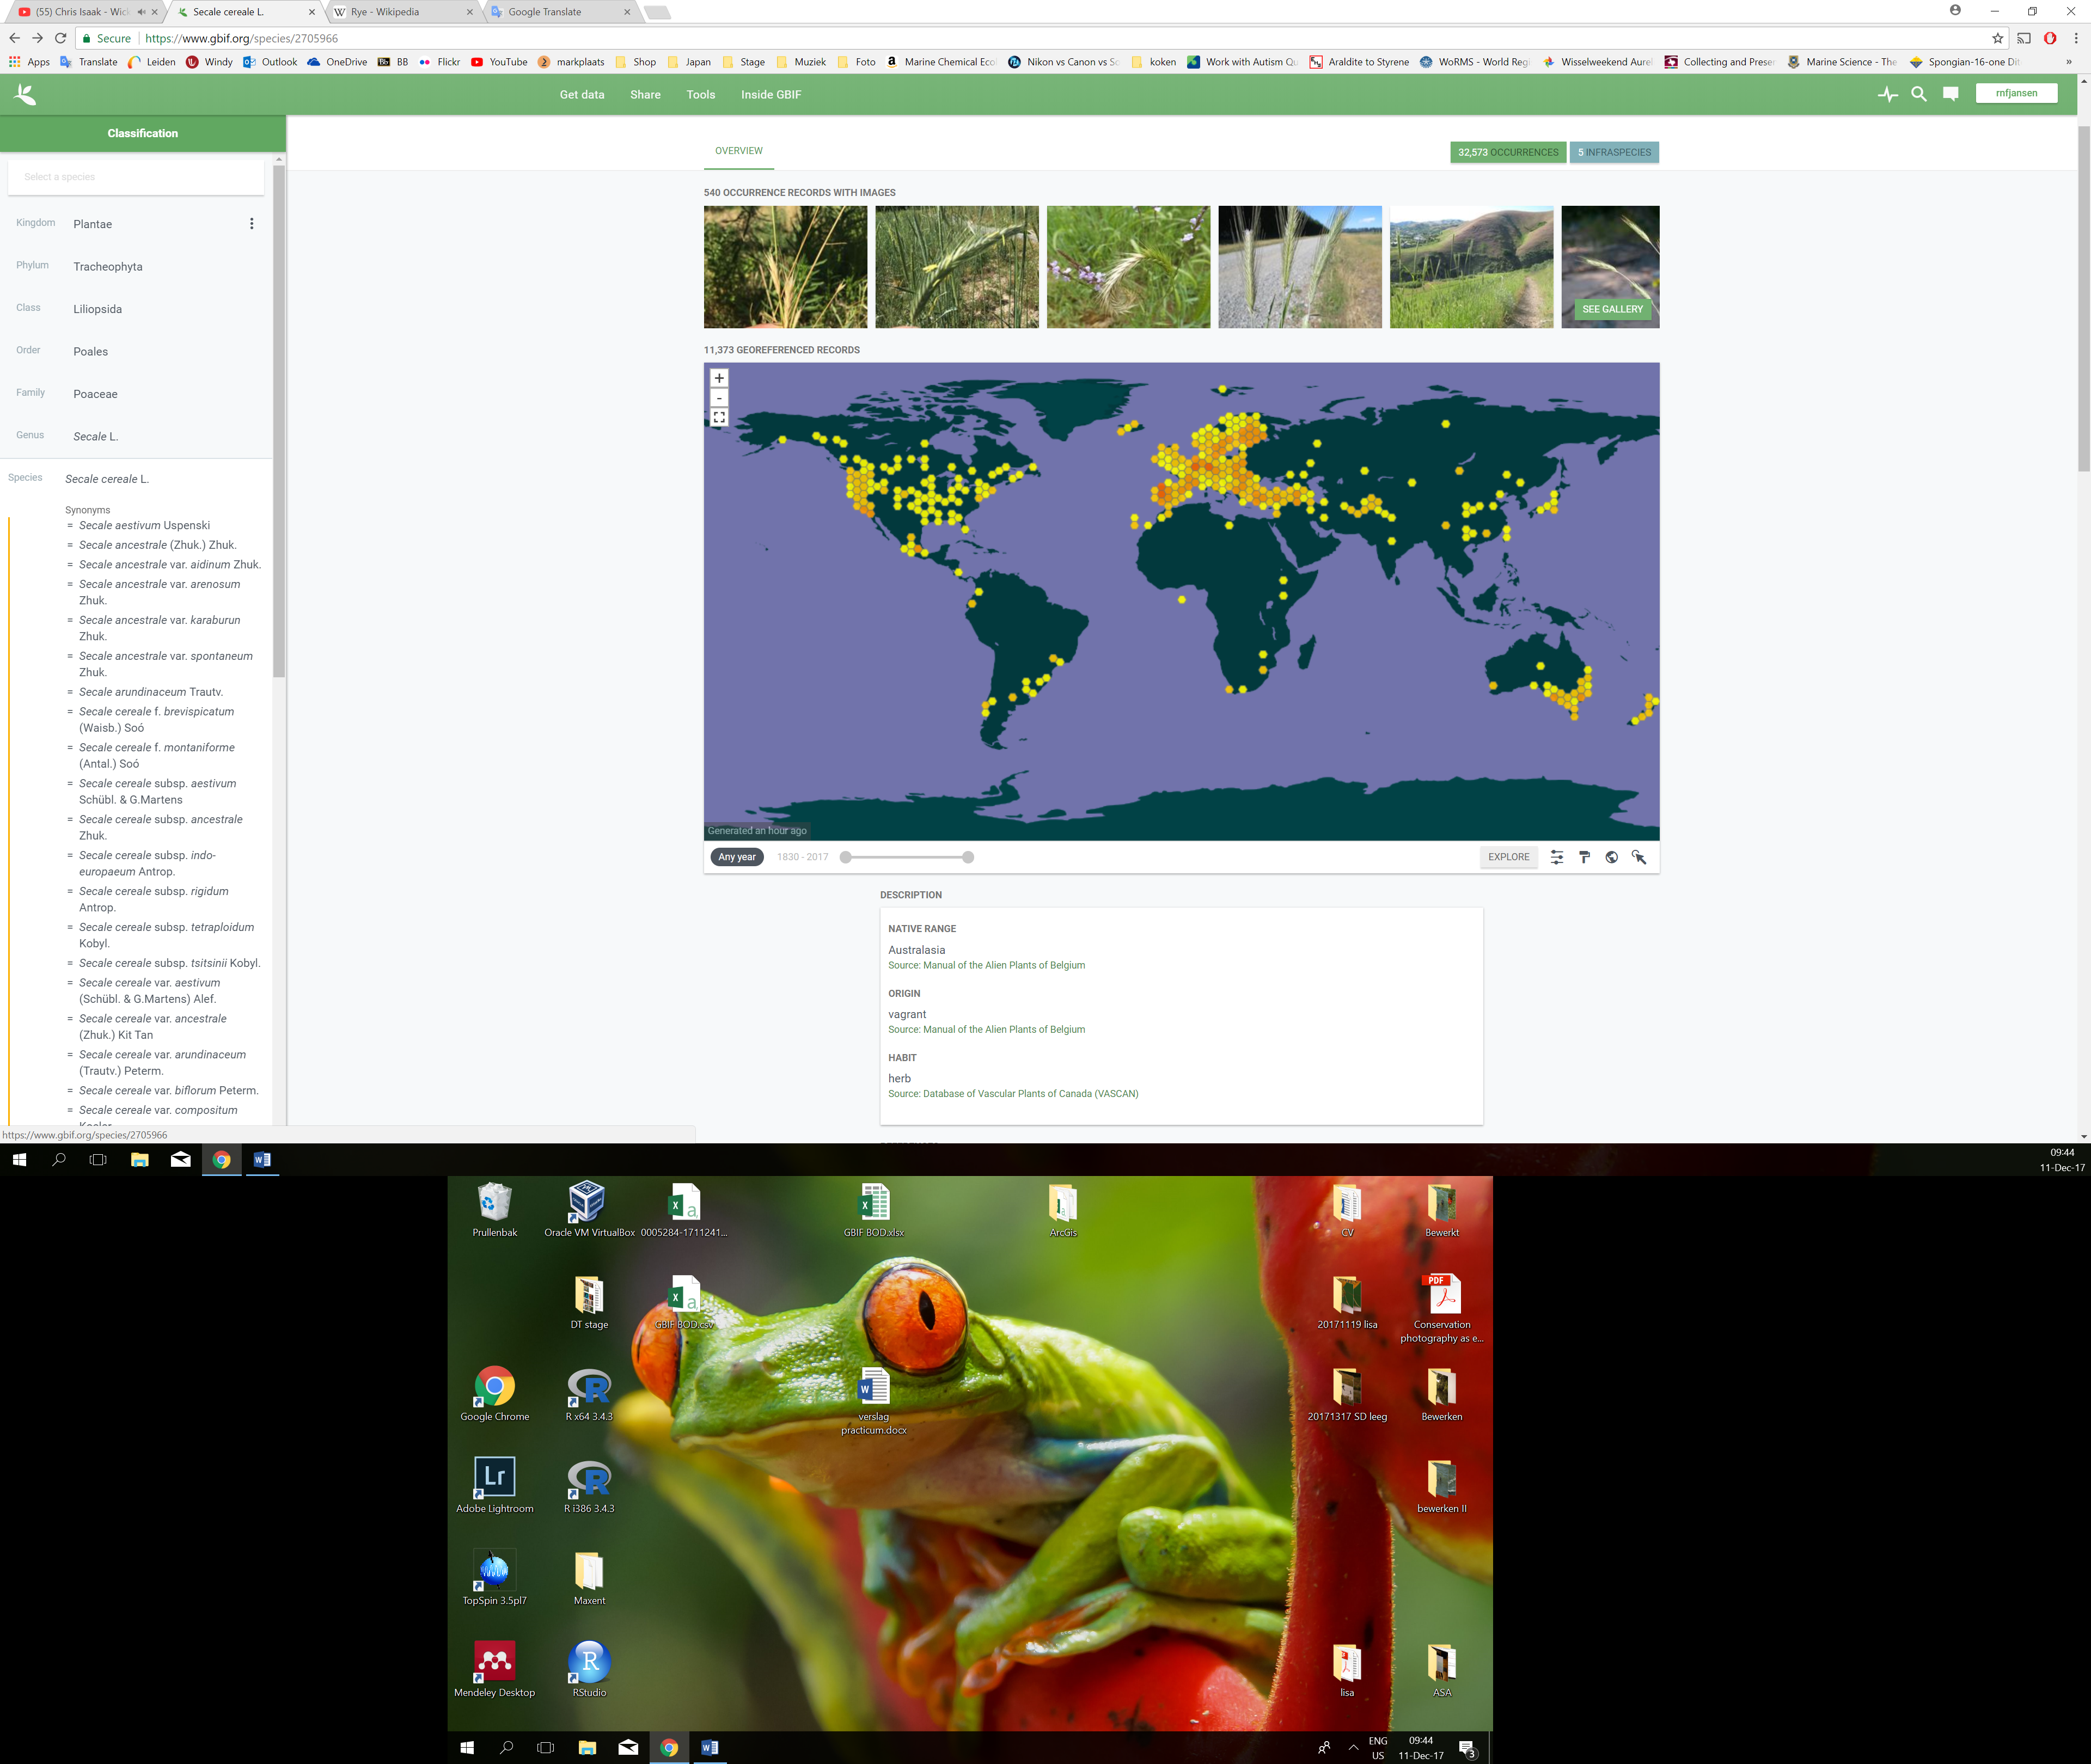

Figure 1. Worldwide occurrence of Rye. Source <https://www.gbif.org/species/2705966>.

**Method**

In the present all georeferenced occurrences Secale cereale from the Netherlands were downloaded from Gbif.org and used to model the worldwide habitat suitability for this crop using MaxEnt. As only the occurrence data from the Netherlands were used in the models to predict the worldwide habitat suitability they will be a bad representation for the actual present and future habitat suitability.

Maxent settings and variables

Climate variables for the present (1960-1990) and future conditions (2070) were downloaded from wolrdclim.org. The spatial resolution of the data of these climate variables is in 5 arc-minutes. As the future temperature is unknow but rising due to climate change a temperature rise of 4.5˚C was chosen for the future climate conditions of 2070. The climate variables for 2070 are projected using the global climate model CCSM4 on worldclim.org.

The climate variables downloaded from worldclim.org were selected based on importance for Secale cereale and tested for correlation using a spearman’s correlation in R. The six selected variables are shown in table 1.

Table 1. Global climate variables selected for the species distribution model. Source worldclim.org version 1.4.

|  |  |
| --- | --- |
| **Temperature** | **Moisture** |
| Mean annual temperature | Precipitation seasonality |
| Temperature seasonality | Precipitation of wettest month |
| Mean diurnal range |  |
| Mean temperature wettest quarter |  |

The species distribution model was created using the maximum entropy method using MaxEnt. The occurrence of Secale cereale for the Netherlands together with the selected climate present and future variables as projection layer and clipped present climate variables to train the model were used as input in MaxEnt. Duplicated records were deleted. The model was created using Linear, Quadratic and Product algorithm parameters meaning that the algorithm constrains the output distribution to have the same covariance for each pair of environmental variables as the samples. The output format was set to logistic to ease interpretation of the output. The amount of presence records is 1165 an the number of background points is set to 10 000.

**Results**

The model shows no chance in the species distribution between the present and future with a +4.5˚C temperature rise. The present and future distribution maps are shown in figure 2 and 3. Figure 4 shows the chance of distribution between the present and future. As this maps only shows yellow there will be no chance in distribution for Secale cereale as projected by this model. The receiver operating curve shown in figure 5 indicates that the model predicts the species distribution well as is has a area under the curve of 0.689. The distribution patterns of the model are meanly driven by the annual mean temperature. The variable importance table is shown in table 2.

Figure 2. Present distribution of Secale cereale based on the model used in the present study. Green is suitable habitat and grey is unsuitable habitat.

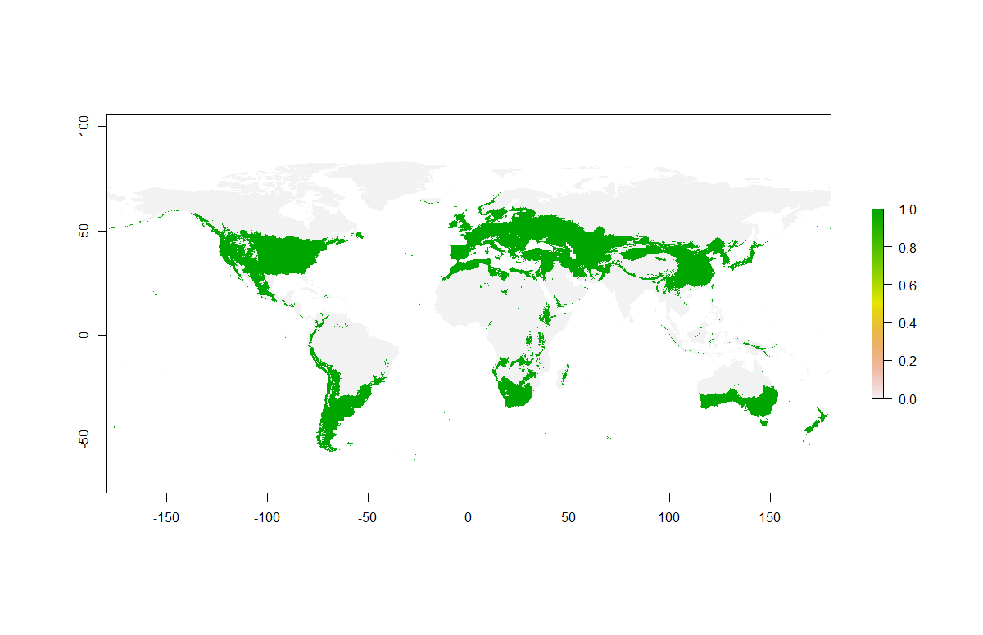

Figure 3. Future (2070, +4.5˚C average temperature) distribution of Secale cereale based on the model used in the present study. Green is suitable habitat and grey is unsuitable habitat.



Figure 3. Change of distribution for Secale cereale based on the model used in the present study. Yellow will remain suitable habitat and grey is unsuitable habitat.

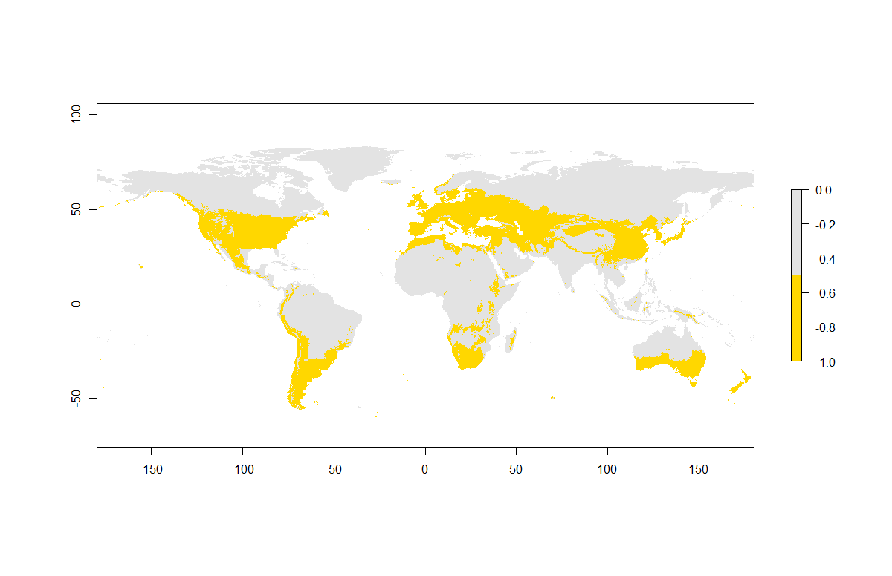

Figure 4. Receiver operating curve for the MaxEnt model to project the species distribution of Secale cereale.

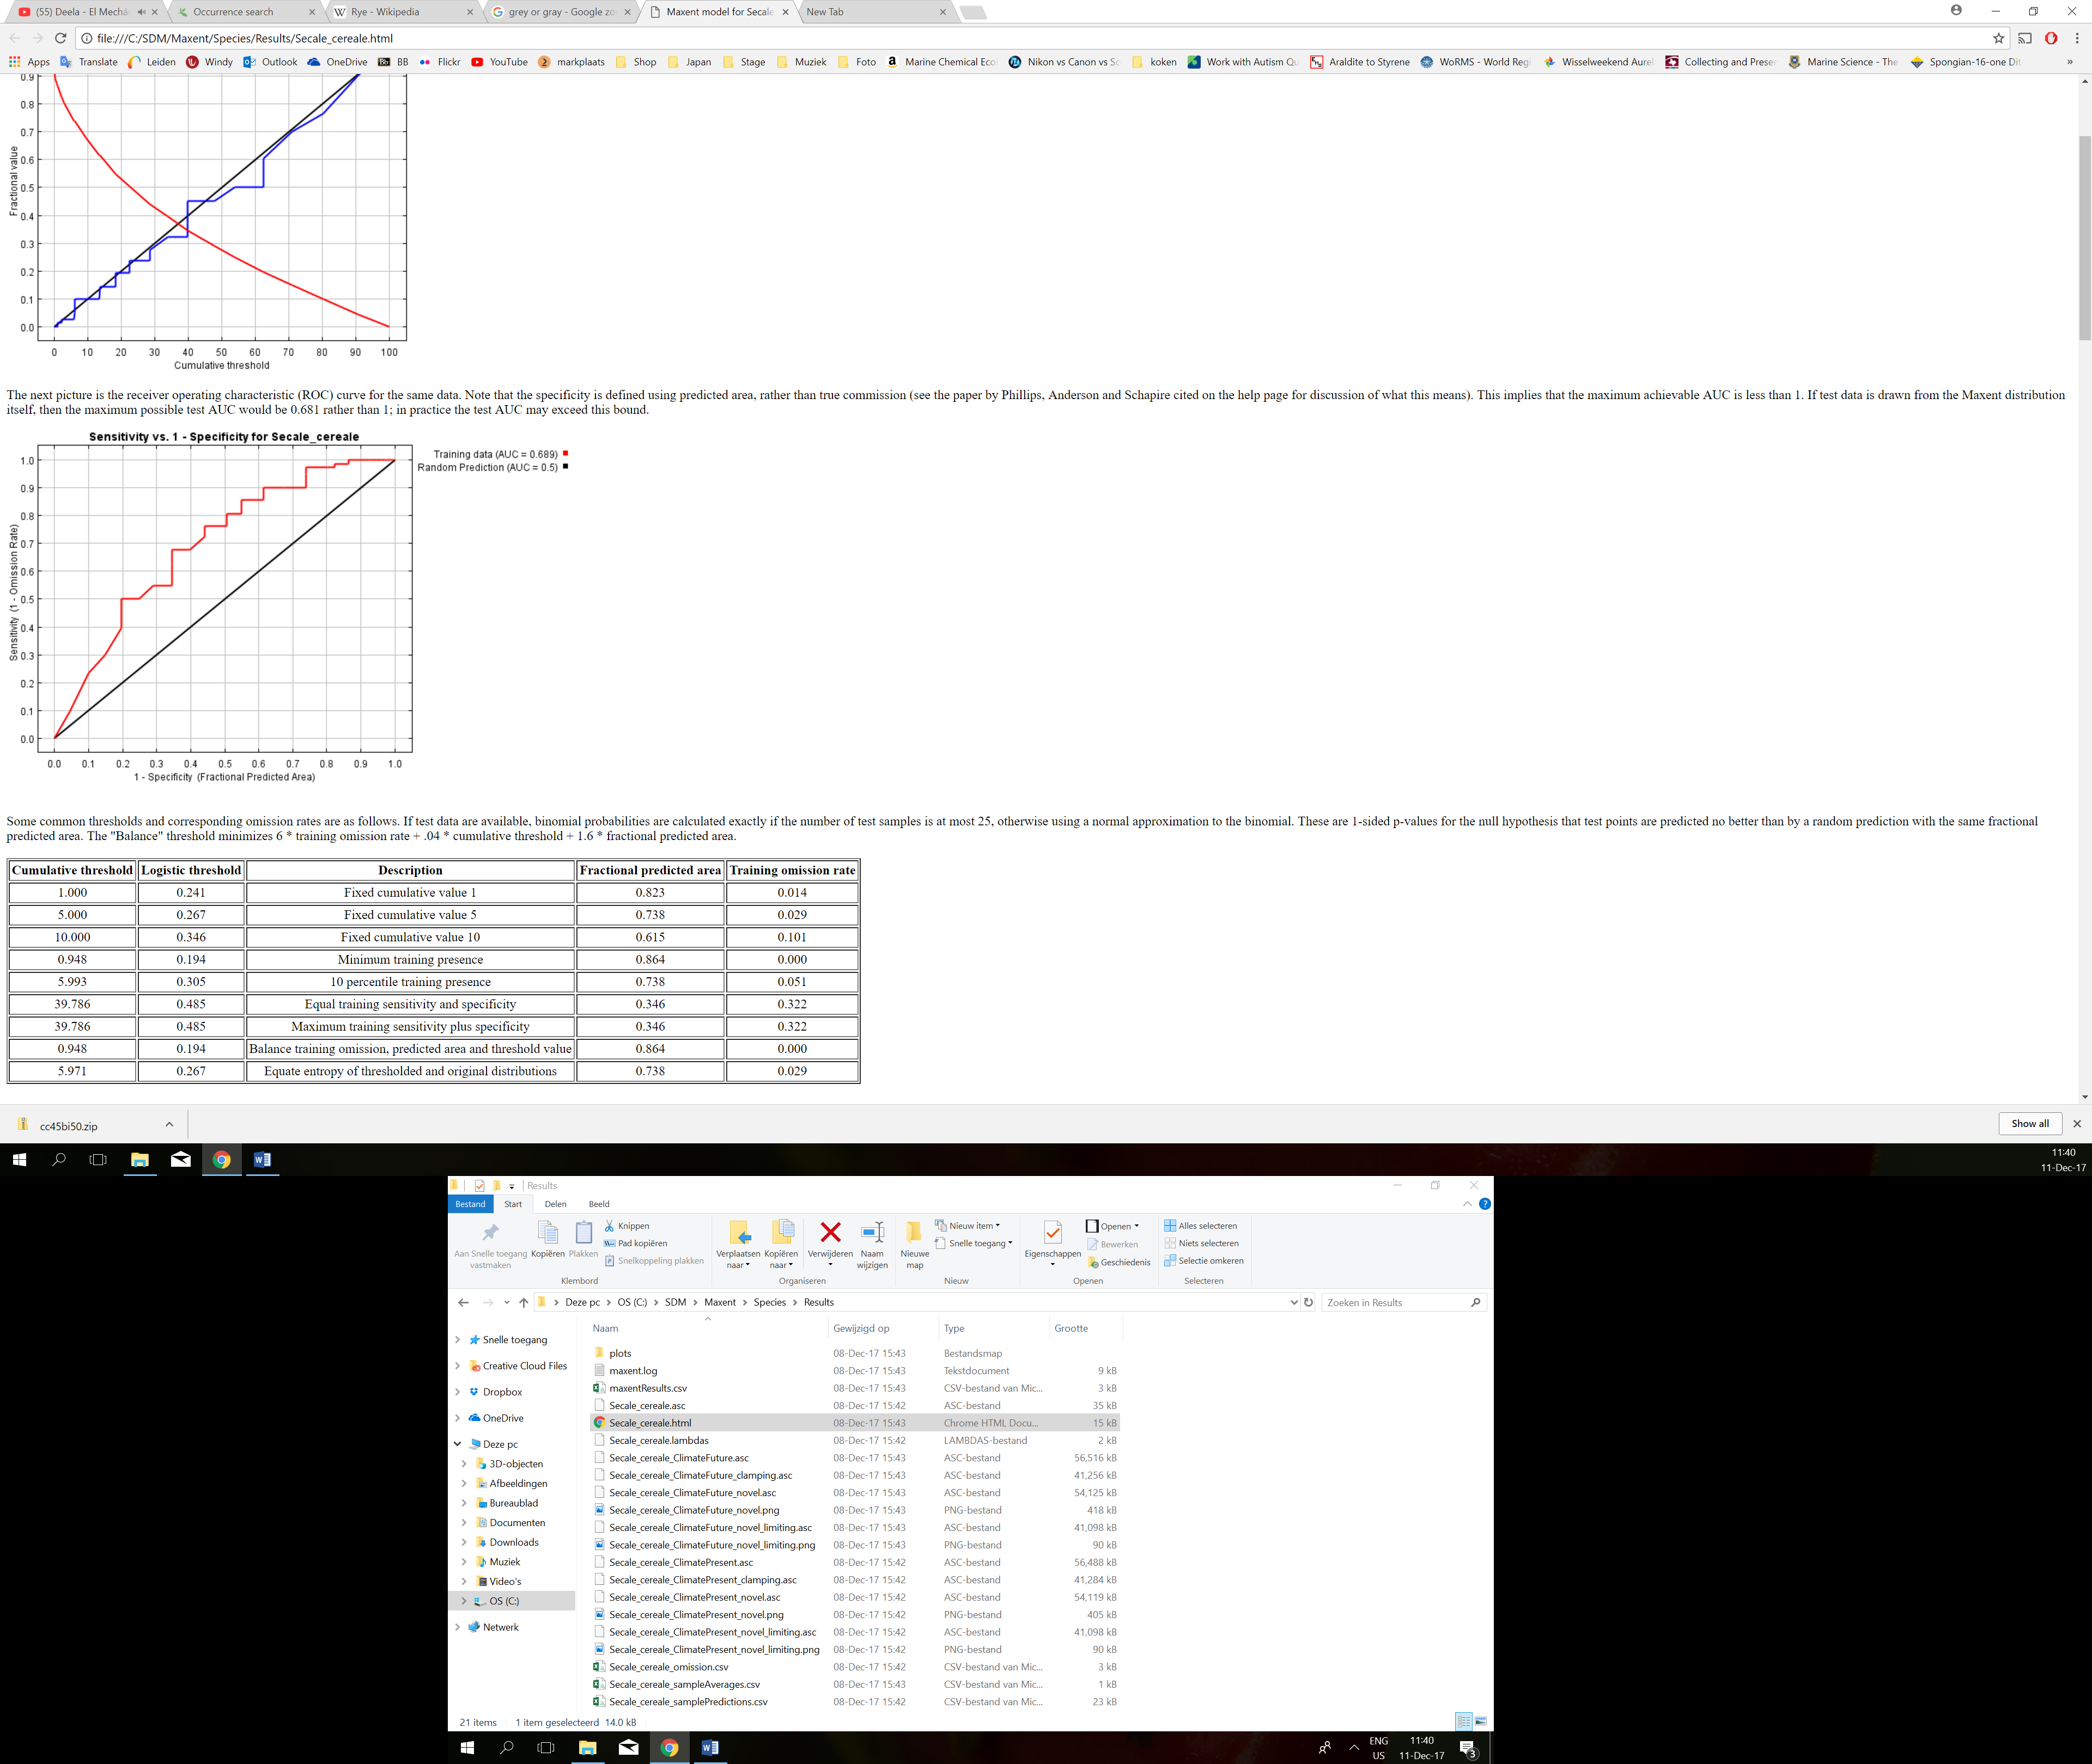

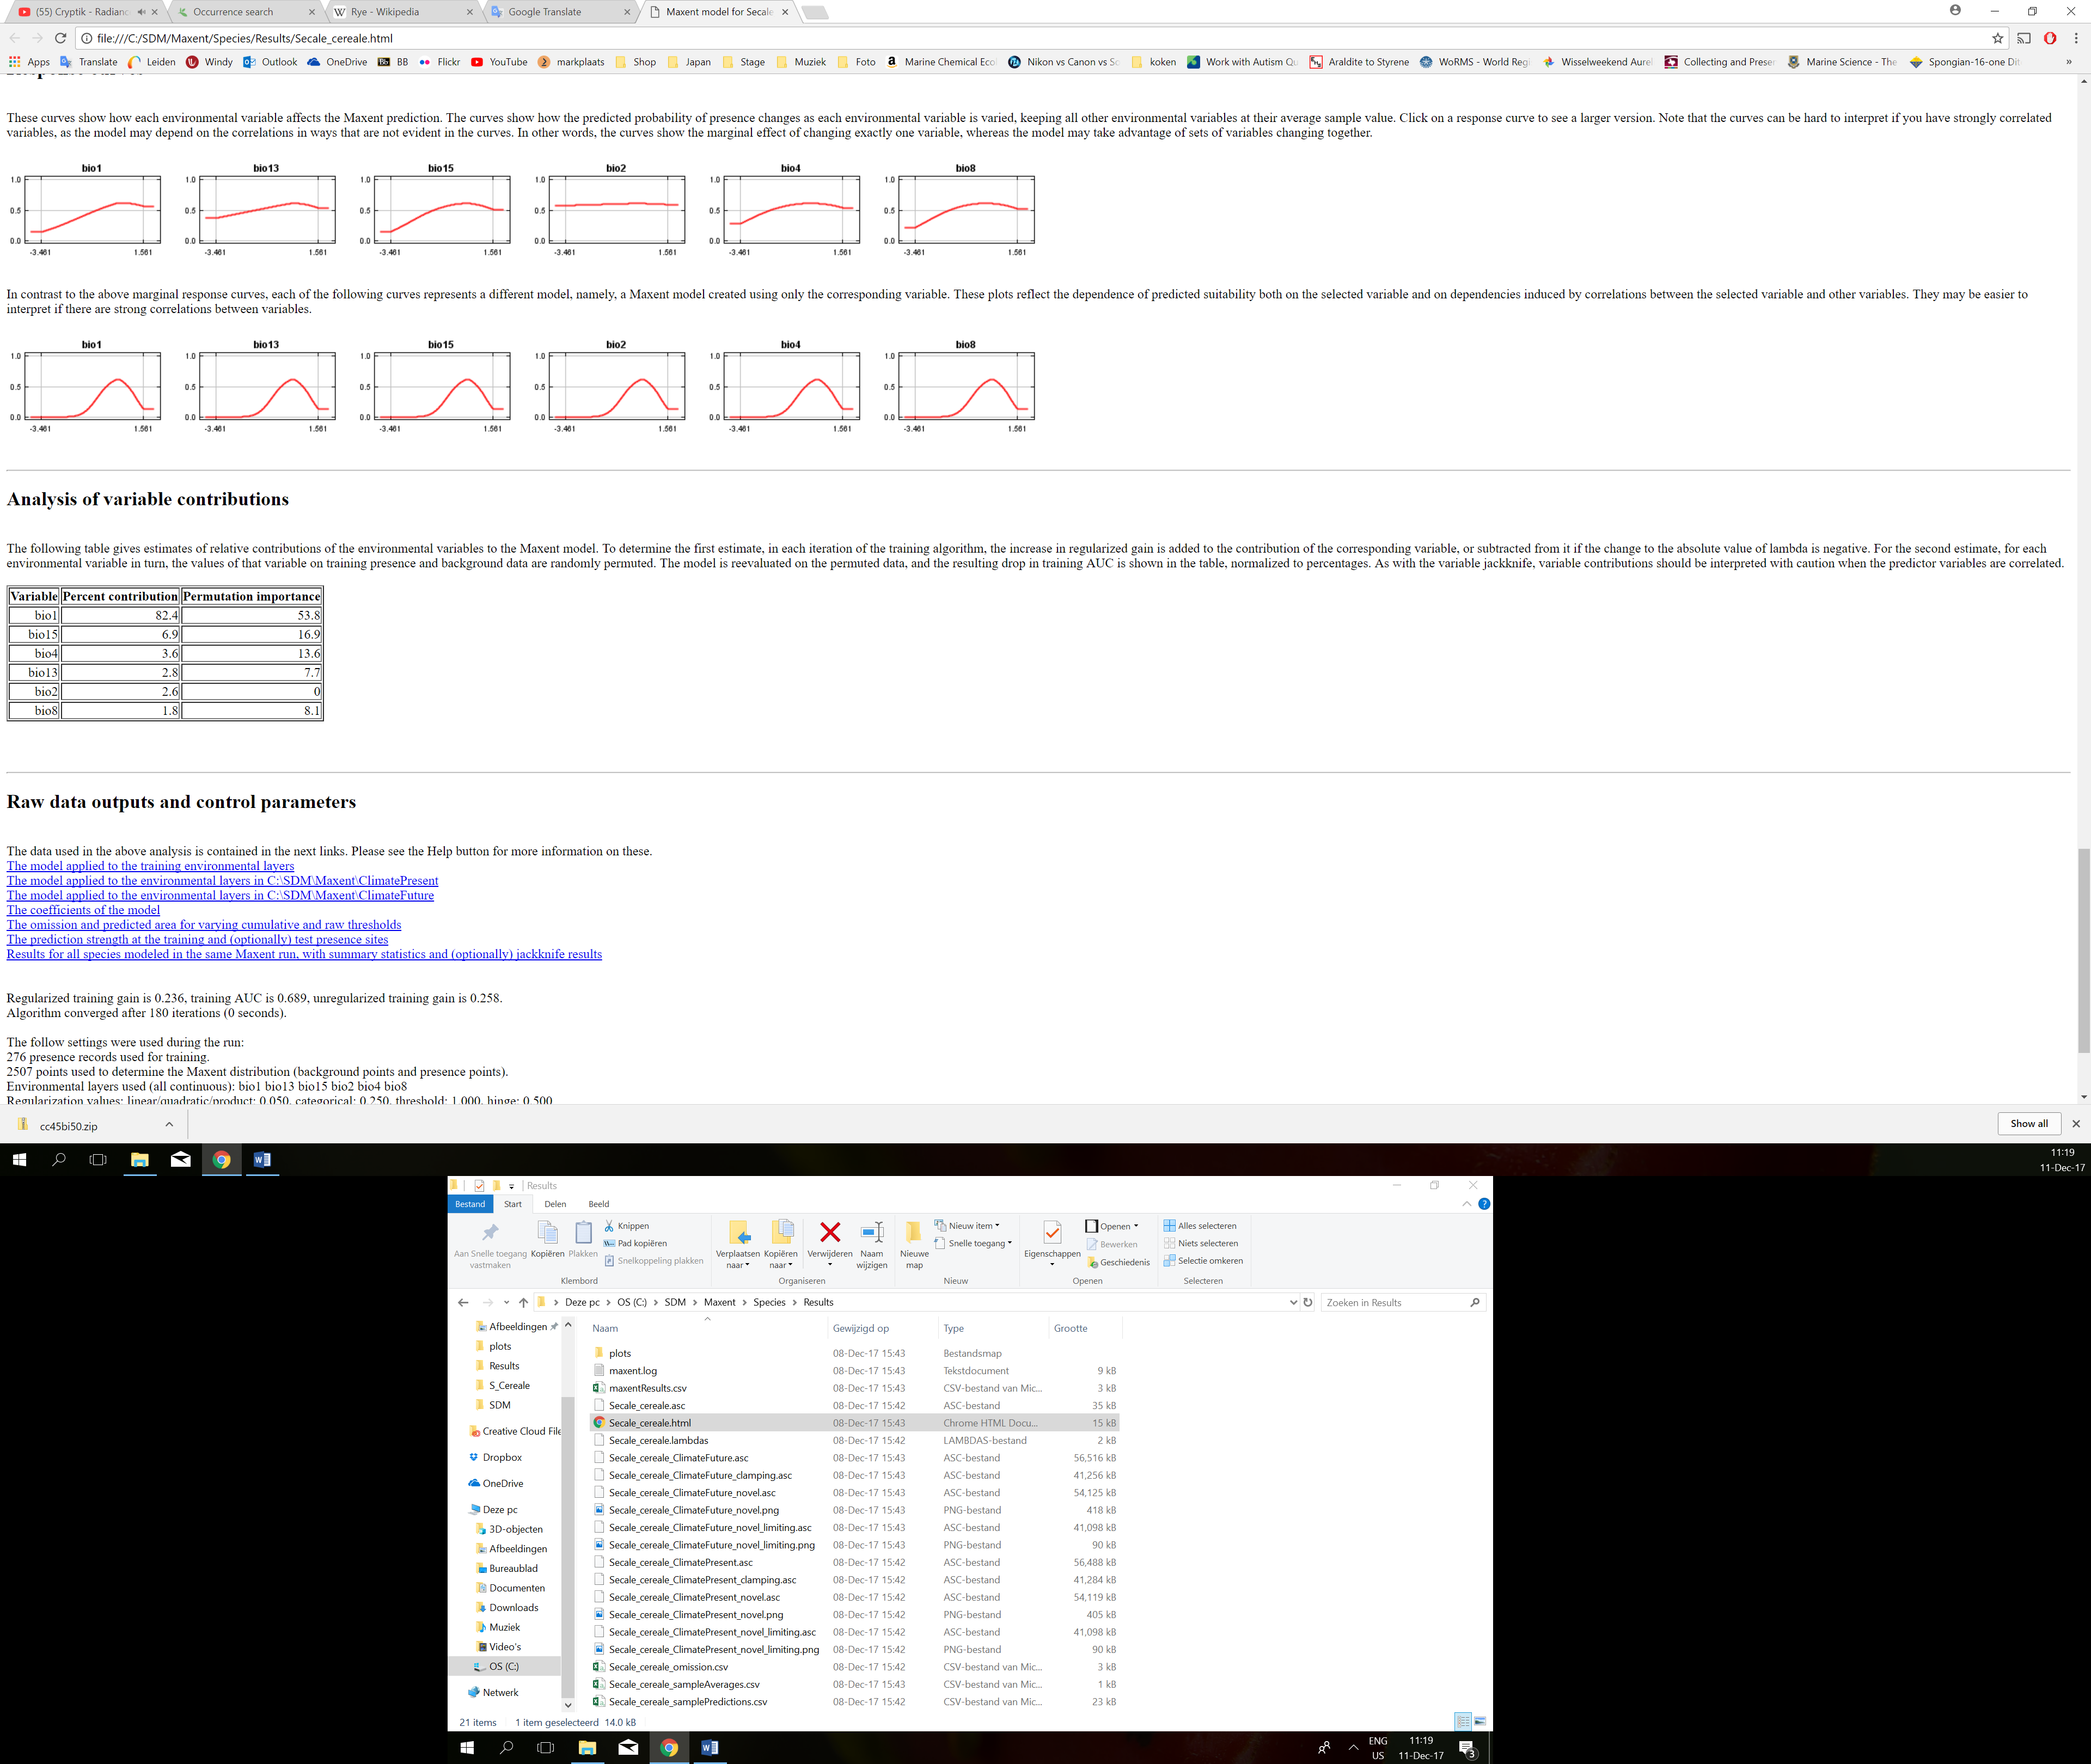

Table 2. Importance of variables for the model of the present study. Higher percentage of contribution means more influence in the model predictions. Bio1: Annual mean temperature. Bio15: Precipitation seasonality. Bio4: Temperature seasonality. Bio13: Precipitation of wettest month. Bio2: Mean diurnal range. Bio8: Mean temperature wettest quarter.

**Discussion**

The distribution of Secale cereale is not expected to change in the future with an average temperature rise of 4.5˚C according to this model. This would mean that the zones where rye is cultivated will remain suitable to produce rye in the future even with a temperature rise of 4.5˚C. Striking is that no new area’s will become suitable to grow rye. As this model shows no change with a temperature rise of 4.5˚C it means that warmers zones in the present are not suitable for cultivation of rye due to other factors then temperature. Therefor a model with precipitation as most important variable might be better suited to model to distribution of rye.

This model is unsuitable to predict the worldwide distribution of rye as only the occurrences data of the Netherlands were used as import. To accurately predict the worldwide distribution of rye the occurrences of all countries should be taken into account.

**Conclusion**

This model is unsuitable to predict these the worldwide distribution of rye and the model predicts no change in the distribution of rye with an average temperature rise of 4.5˚C.